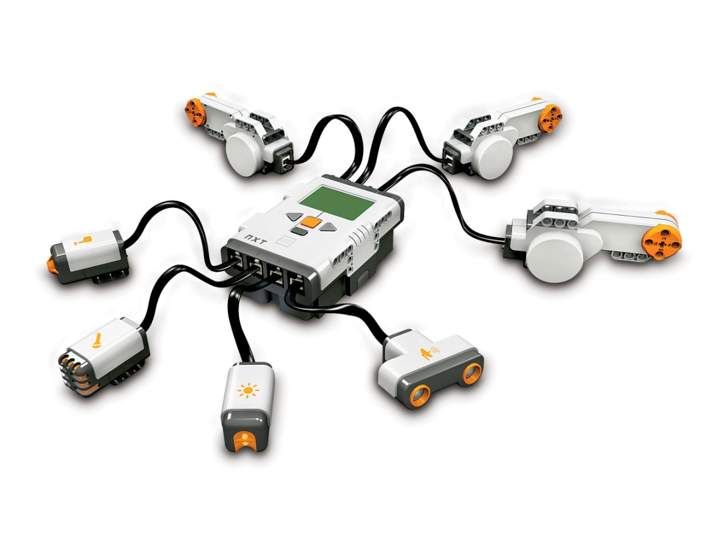
- Use this picture to identify 7 different electronic components:

